Lab 14: Containers and Cursors
Covering Lectures: Lectures 40 - 42
Objective:
This Lab aims to give students a deep understanding of various STL containers in C++.
Learning Outcomes:
After completing this lab, students can practice sequence, associative, and container adapters and explore their properties and use cases.
Problem Statement:
Design a mini-library system that uses multiple STL containers:
- Use a map to store books with the book title as the key and the book's information (author, publication year, etc.) as the value.
- Use a queue to manage a waiting list for borrowing a book.
- Use a vector to store the list of currently available books.
- Implement functionality for adding books, borrowing books, and managing the waiting list.
Sample Output:
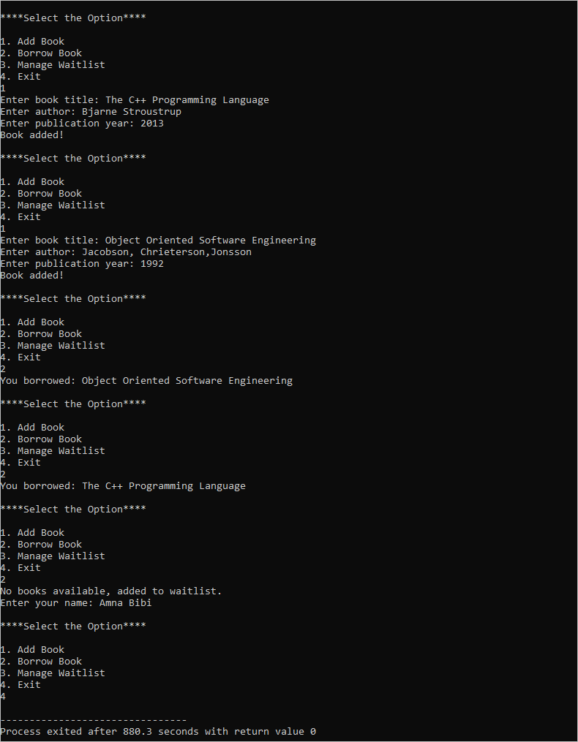

Practice Questions:
- Write a program that reads a string from the user, splits it into words, and uses set to display all unique words in the string.
- Create a task scheduler that allows the users to add tasks with different priorities (higher numbers indicate higher priority). The tasks should be stored in a priority_queue, and the program should always execute and remove the highest-priority task first.

